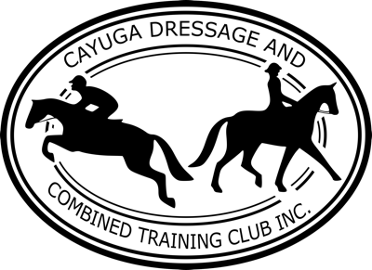
Cayuga Dressage and Combined Training Club is seeking sponsors for our annual recognized shows!
CDCT Dressage in
Wine Country I & II
August 27 & 28, 2022
Chemung County Fairgrounds, Horseheads, NY

There are two ways you can support our show!
- Become an Elite Sponsor by donating funds or goods valued at any of the levels listed below. Your sponsorship will be announced over public address as well as be publicly displayed around the show grounds. You will also receive year-round recognition on our website, www.cayugadressage.org
Elite Sponsorship Levels: Grand Prix - $1000.00
Piaffe - $500.00
Passage - $250.00
Flying Change - $100.00
- Sponsor a Special Award to be given out during our Wine and Cheese Gala, held during the show. Our infamous Special Awards include fun ribbons and themed baskets designed by the donor. To sponsor a Special Award, give a $35.00 donation to CDCT and then dream up a unique award idea and curate a basket of goods (valued around $50). Your donation covers the unique ribbon!
I want to sponsor a Special Award: $35 Donation to CDCT + Basket Valued at $50
Name of Special Award/Short Description:
---------------------------------------------------------------------------------------------------------------------------------------
Name: Phone:
Address:
Email:
Name of person/business to appear on our website and be announced during the show:
Please fill out all of the information on this form and return it along with a check or donate via PayPal (dressageithaca@gmail.com). If you are donating goods, please indicate below how we will receive your goods.
I will be: bringing my goods; mailing my goods; needing goods picked up.
Elite Sponsors mail to: Kathy Thode, 4198 Duryea St., Moravia, NY 13118
Special Awards mail to: Jane-Marie Law, 16 Muriel St., Ithaca, NY 14850

